[Insert Clinic Logo]
[This can be used to obtain email addresses for newsletters and information sharing]

CLIENT INTAKE FORM

Name: _____________________________________________________ Date: ______________
Hand Dominance: □ Right □ Left Age: ______________

How did you hear about our services? □ Doctor □ Nurse practitioner/PA □ Chiropractor □ Friend/family
□ Internet □ Other: ______________________________________
*Your email address: ______________________________________________________________(optional)
Your email is used share information about your diagnosis, healthy life style tips, and monthly newsletters …

WORK INFORMATION
Are you currently employed? □ Yes □ No
What is your job title/position? ________________________________________________________________
What are your job duties/responsibilities? _______________________________________________________ _________________________________________________________________________________________
What is your work status? □ Full-duty □ Full-time □ Part-time □ Restrictions □ Retired
□ Light-duty □ One-handed □ Off-duty □ Disability □ Student

PAST MEDICAL HISTORY
Please circle any past or current medical problems you may have:

Cardiac Heart Failure Cancer Stroke
Pacemaker High Blood Pressure Head Injury
Cardiovascular Disease Diabetes Neck or Back pain
COPD Gout
Irregular Heart rate Arthritis
Other (please list): _________________________________________________________________________

Please check if you are a □ non-smoker □ smoker. Have you fallen in the last 6 months? □ Yes □ No

Please list any previous neck, shoulder, arm, and/or hand surgeries and/or injuries:_______________________
_________________________________________________________________________________________

Do you have any metal implants or artificial joints? □ Yes □ No

Do you have any allergies? Please specify: ______________________________________________________

Are you taking any medications? Please list: _____________________________________________________
_________________________________________________________________________________________

Have you had any of the following tests performed for your current problem:

Test Results:
X-rays □ Yes □ No _____________________________________________________
Nerve conduction test □ Yes □ No _____________________________________________________
EMG □ Yes □ No _____________________________________________________
CT Scan □ Yes □ No _____________________________________________________
MRI □ Yes □ No _____________________________________________________

PLEASE SEE OVER

SYMPTOMS
Please use this diagram to circle any problem areas:

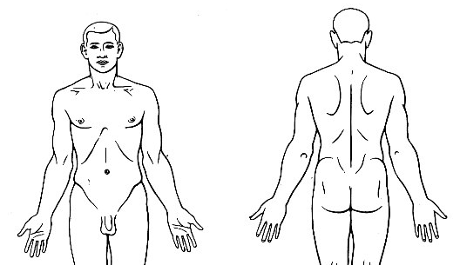

PAIN
On a scale of 0 – 10, circle the number that best describes the intensity of your worst pain in the last week.
0 = no pain, to 10 = worst pain you could imagine.

0 1 2 3 4 5 6 7 8 9 10

TELL US ABOUT YOUR CURRENT CONDITION…
Date of injury: _____________________________________________________________________________
Date of surgery: ___________________________________________________________________________
What happened? Briefly describe your current problem/symptoms: ___________________________________
_______________________________________________
Have you ever had these symptoms before? When? _______________________________________________
Previous treatment for this problem? ___________________________________________________________
What makes it better? _______________________________________________________________________
What makes it worse? _______________________________________________________________________
Have you tried any devices or orthoses? _______________________________________________________
How does this impact your life? What can’t you do as a result? _______________________________________
_________________________________________________________________________________________
What hobbies/recreational activities do you enjoy? Are you having any difficulties performing these activities?
_________________________________________________________________________________________
What are your goals in coming to therapy? _______________________________________________________
_________________________________________________________________________________________
THANK YOU!

